/Users/nesh/Documents/Repositories/ice2021/crystals/2023-07-20/50pa/case2.0 (calibration)

Segments2, basal. Looks like TLK.
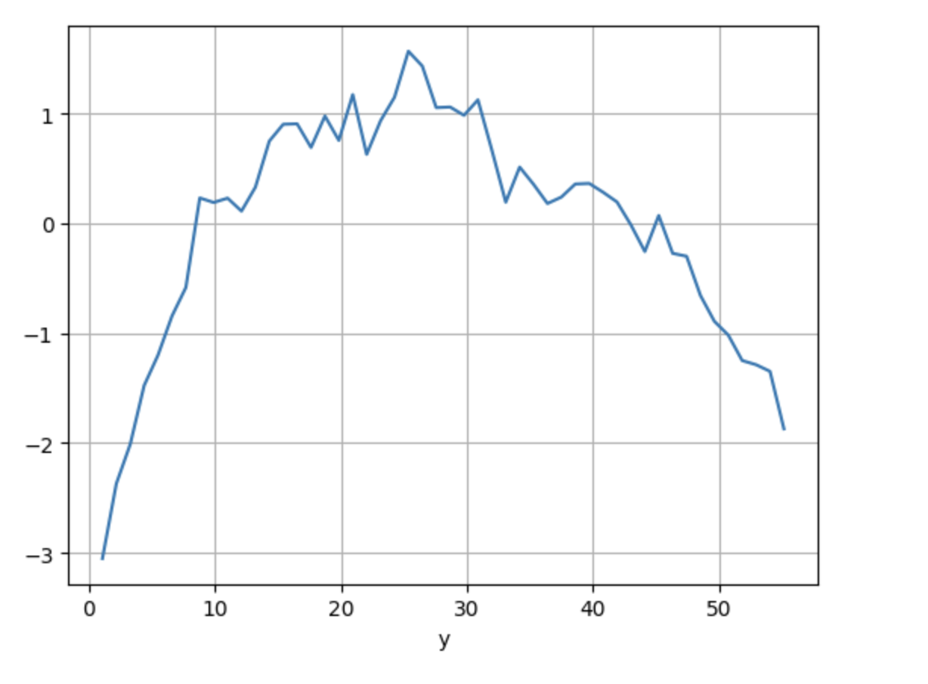

Segments10, prismatic. This looks like TLK on the left, RDQ-2 on the right.

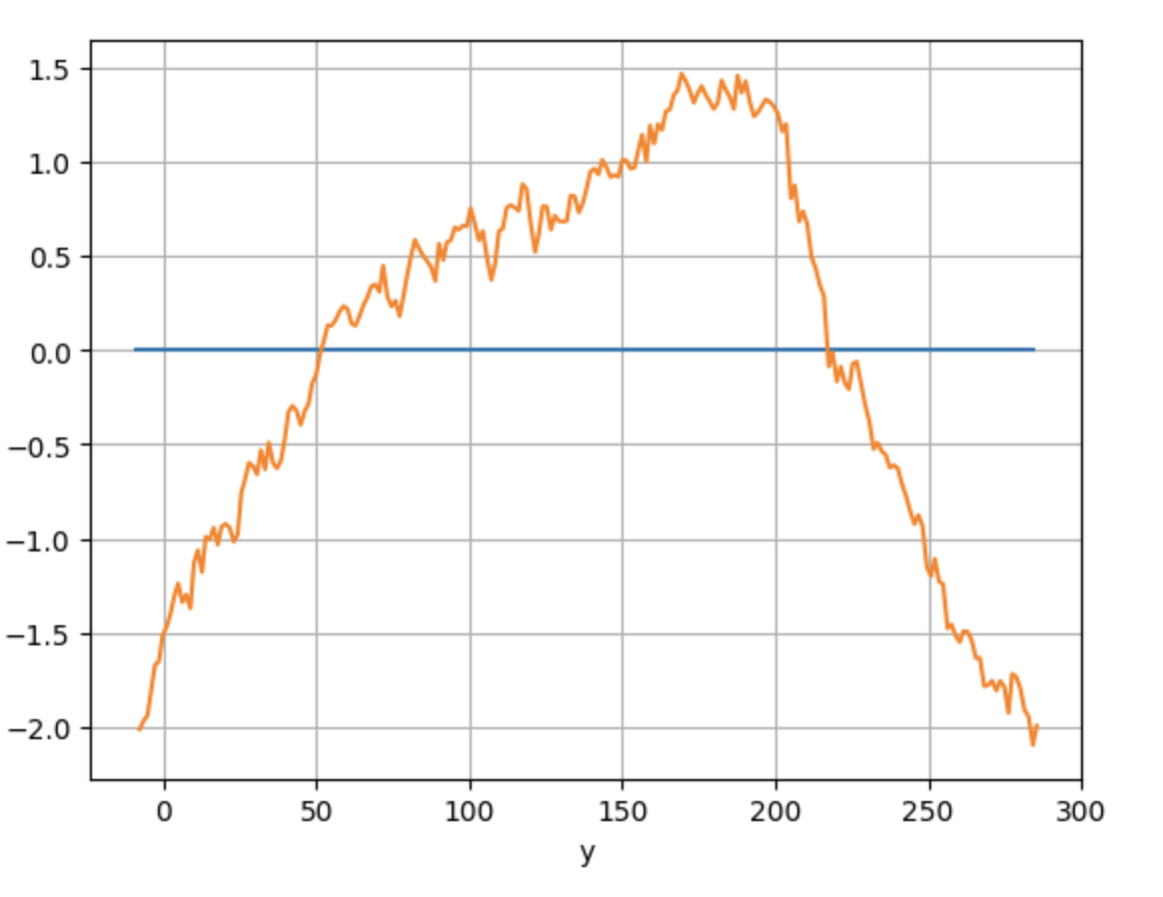

Segments11, pyramidal. Looks like RDQ-2 on the left, TLK on the right.


